Explain the following questions in two simple sentences

1. What is the use of the git add command?

It tells Git to start tracking changes you’ve made to files, preparing them for commit Basically, it moves your updated files into the staging area.

1. Write the command to create a branch “feature-group”.

git branch feature-group

* (or directly switch with `git checkout -b feature-group`).

1. What is a pull request? Write the steps involved in creating a pull request.

A pull request lets you tell others you’ve pushed changes to a branch and want them merged into the main code.

* To create it: push your branch, go to GitHub, click “Compare & pull request”, review it, and create the pull request.

1. How do you add collaborators?

Go to GitHub repository ➔ Settings ➔ Collaborators ➔ add username or email so they can work on current project.

1. What is the command used to commit our changes in github repo?

git commit -m "Commitr message"

1. Create a github account and repository to save all your assignment tasks. Example repository name: rg-assignments:

* git@github.com:sanjana-singamsetty/rg-assignments.git

1. Create a branch called feature-java(you can use it later to push all your java related tasks to this branch)
2. Install IntelliJ IDE. Create a simple java project displaying “Hello World!!”and share the screenshot.

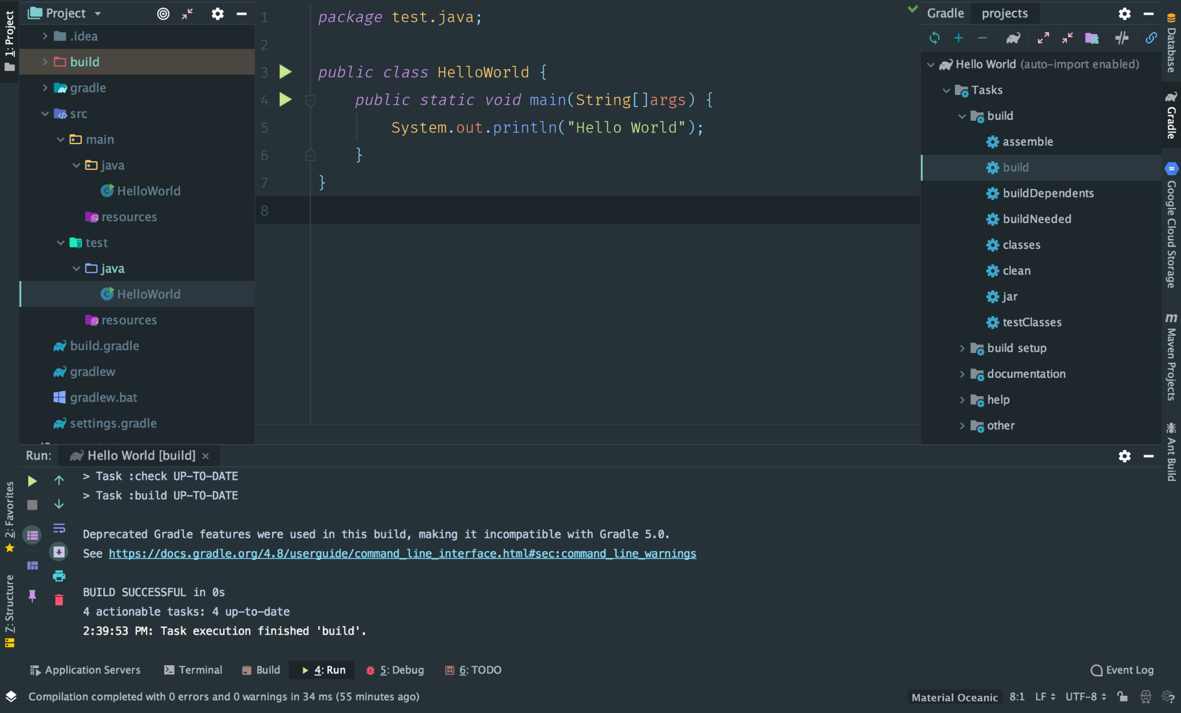

1. In IntelliJ IDE, explore the shortcut keys for the following
   1. To run the project
   2. To select a line
   3. To comment/uncomment a line
   4. To delete a line

* Done